

Enterprise Inc. Presents

**CSC 430 Payroll Program**

This software is used to help manage company personnel, calculate for them after-tax salary, welfare items, as well as edit and manage the personal information of each employee.

**Table of Contents:**

1. **Logging in**
   1. **Logging in as Human Resources……..p. 3**
   2. **Logging in as an employee…………….p. 3**
2. **Employee Interface**
   1. **Editing general information……………...p. 4**
   2. **Viewing benefits packages……………....p. 4**
   3. **The tax screen……………………………...p. 5**
   4. **Viewing gross income…………………….p. 5**
   5. **Viewing net income………………………..p. 5**
   6. **Info panel on other employees………….p. 5**
3. **HR Interface for Employee Info**
   1. **Adding a new employee…………………..p. 6**
   2. **Retrieving/Editing an employees info…..p. 6**
   3. **Deleting an employee from the system…p. 6**
   4. **Unlocking a locked employee…………….p. 7**
4. **HR Interface for Employee Benefits**
   1. **Retrieving the benefits package of an employee...p.8**
   2. **Updating the benefits package of an employee….p.8**
   3. **Removing the benefits package of an employee...p.8**
5. **HR Interface for Employee Tax Info………………………..p.9**
6. **HR Interface for Gross Pay**
   1. **Retrieving an employee’s gross income…………..p.10**
   2. **Updating an employee’s gross income…………….p.10**
7. **HR Interface for Net Pay**
   1. **Viewing the employee’s net income………………..p.11**

**8) HR Interface for Former Employees**

1. **Viewing Former Employee Info……………………..p.12**
2. **Editing Former Employee Info……………………...p.12**
3. **Deleting a Former Employee………………………..p.12**

**9) Error Handling**

* 1. **Error dialogs…………………………………………....p.13**

**Logging In**

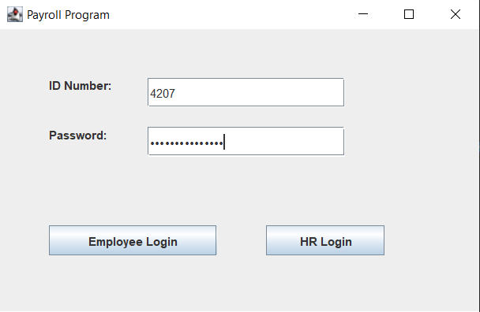

**Logging in as Human Resources**

For an HR Member to log into the program, they must input their assigned HR ID and password.

**Logging in as an Employee**

For an employee to log into the program, they must input their assigned Employee ID and password. Each employee will be given three chances to input the correct information. If they do not input the correct information after three chances, they will be locked out of the system and must have an HR member reset their password.

**Employee Interface**

After logging in, employees will have five options at the top of their screen. These options will be: Employee Info, Employee Benefits, Employee Tax Info, Employee Gross Pay, and Employee Net Pay. For each of these options, they will be able to view the information in their respective category.

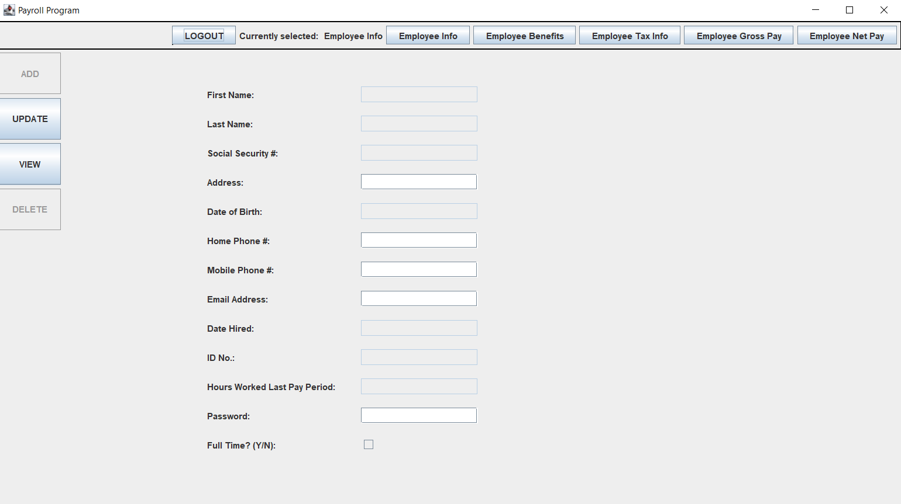

**Editing General Information**

In the “employee info section”, employees will have the option to not only view, but update some of their information. This includes their address, phone numbers, email address, and password. To do this, employees must modify the info they wish to update, then click the “UPDATE” button on the left side of their screen. Note that employees will not be able to update other information including their Name, SS#, DOB, Date Hired, ID#, and Hours Worked Since Last Pay Period.

**Viewing Benefits Packages**

For an employee to view their currently chosen Benefits package, they must simply click on the “Employee Benefits” page seen at the top of their screen. This will show the name of the Benefits package they’ve chosen (Bronze, Silver, or Gold) as well as what is included in their package.

**The Tax Screen and Tax Deductions**

Employees have the ability to see what taxes they will be paying by going to the “Employee Tax Info” page. This is located at the top of their screen and will show the taxes of employees living in New York. This includes Federal Income, State Income, Local Income, Medicare, and Social Security.

**Viewing Gross Income**

To view their gross income, employees have to simply click the “Employee Gross Pay” page at the top of their screen. Although many employees disagree, they will not be able to modify their gross income.

**Viewing Net Income**

The net income is an employee’s gross income with the calculation of taxes and benefit costs deducted. In order for employees to view their net income, they must choose the “Employee Net Pay” page at the top of their screen.

**Viewing Other Employees**

We have added the ability for employees to view basic information of other employees. Employees can use this option if they wish to get into contact with the other employees in the workplace. To view an employee’s basic information, click “VIEW” on the left side of the screen and input the ID Number of the employee you wish to view.

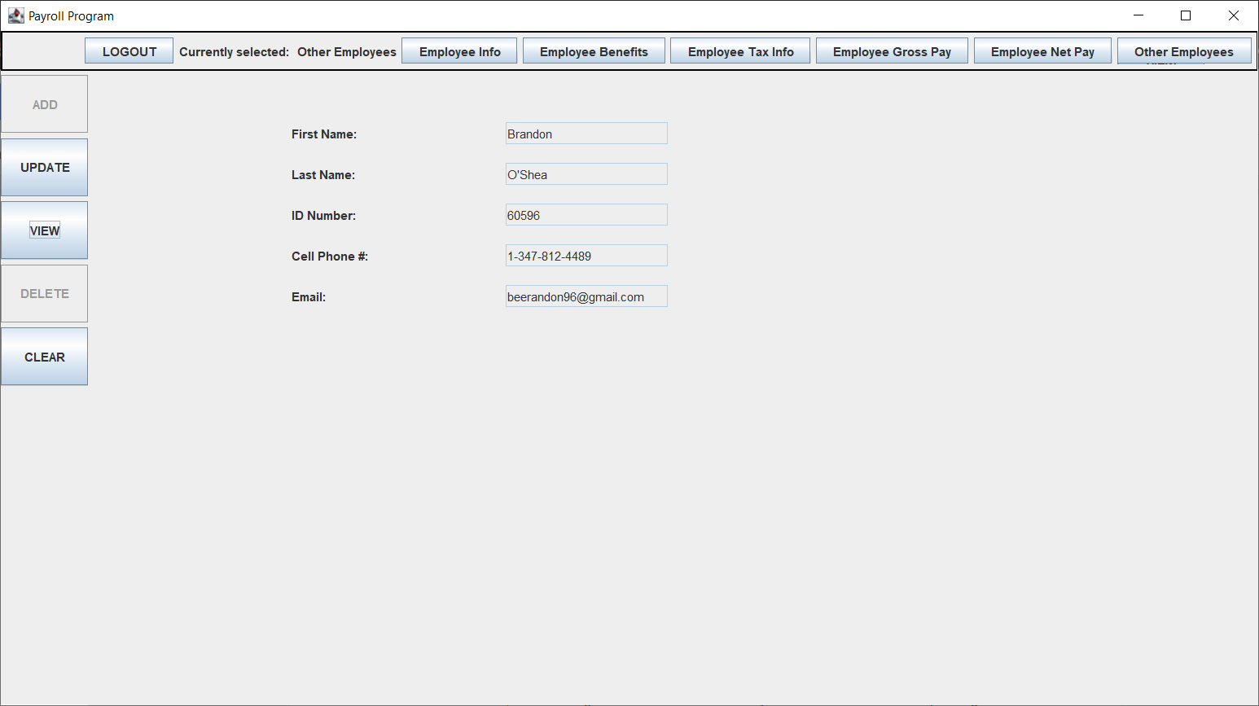

Also, when employees view info on other employees they do not see any sensitive info on that employee, such as their social security number or their password.

**HR Interface for Employee Info**

When HR Members select the “Employee Info” screen, they will be able to ADD, UPDATE, VIEW, and DELETE information for any given employee. The information they will be able to modify is the full name, SS number, address, date of birth, home and mobile phone number, email address, date hired, employee ID number, hours worked since last pay period, employee password, and if the employee is full time or part time.

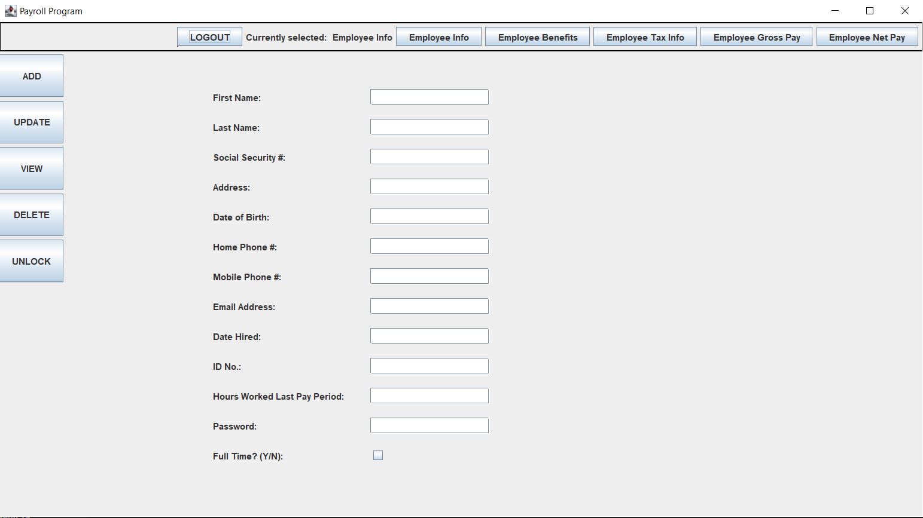

**Adding a New Employee**

To add a new employee into the system, the HR Member must first fill out all the information for the employee. After all the information is filled out on the screen, the HR Member can click the ADD button on the left of their screen to finalize the input information.

**Retrieving/Editing Employee Info**

If any employee information needs to be changed, an HR Member can do this by modifying what needs to be modified, then by clicking the UPDATE button on the left of their screen. The difference between the UPDATE and ADD function is that the UPDATE function does not create a new instance of an employee.

**Deleting an Employee from the System**

If an employee needs to be deleted from the database, an HR Member must be on the Employee Info page of the employee, and must simply click the delete button. This will remove all their information from the database, and free up their ID for a new employee

**Unlocking a Locked Employee**

An HR associate can use the UNLOCK button to unlock the account of an employee that has been locked out due to too many failed attempts at logging in. A dialog box will appear where they can simply enter the ID of the employee and it will unlock them.

**HR Interface for Employee Benefits**

On the “Employee Benefits” page, HR Members have the ability to view and edit the Benefits Package each employee has, as well as what benefits are included in each package.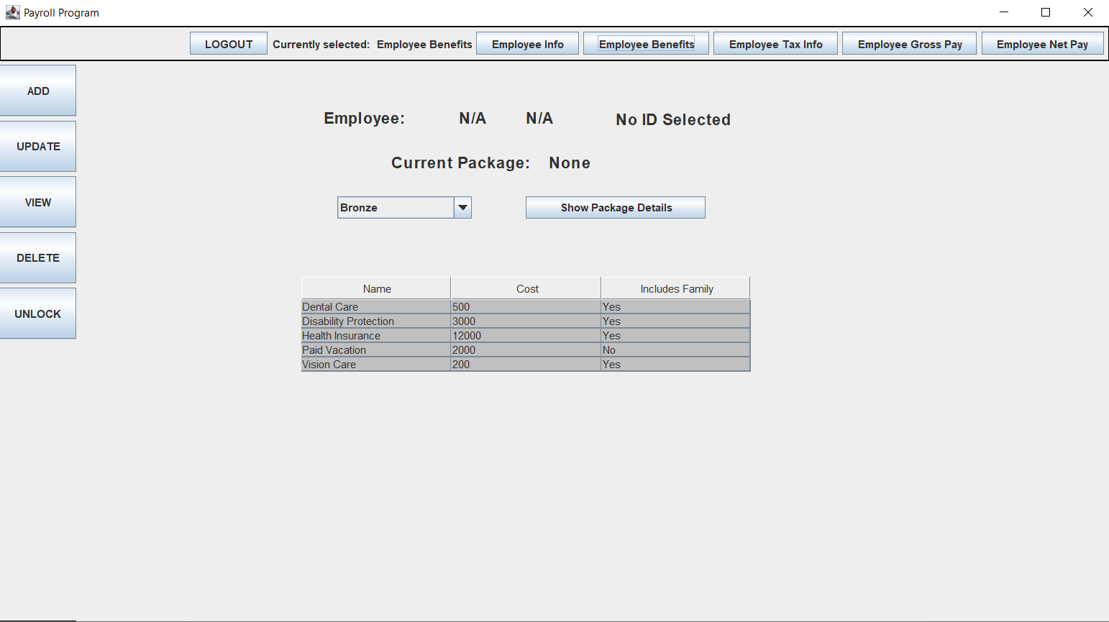

**Retrieving the Benefits Package of an Employee**

For an HR Member to view the Benefits Package of a selected employee, they must have the ID of the employee and must simply click VIEW on the left side of their screen while on the “Employee Benefits” page.

**Updating the Benefits Package of an Employee**

If an employee wishes to change their Benefits Package, an HR Member must go to the employee’s “Employee Benefits” page. By clicking the UPDATE option on the left side of their screen, the selected employee will be given the benefits package currently selected.

**Removing the Benefits Package of an Employee**

If an employee no longer wants their benefits package, an HR Member must go to the employee’s “Employee Benefits” page and click the DELETE button on the left side of their screen. This will remove their Benefits Package from their name in the database, and will no longer be charged for in the Net Income.

**HR Interface for Employee Tax Info and Tax Deductions**

On the “Employee Tax Info” page, HR Members will be given information about the tax percentages taken out from each employee’s gross pay. This information cannot be modified in any way.

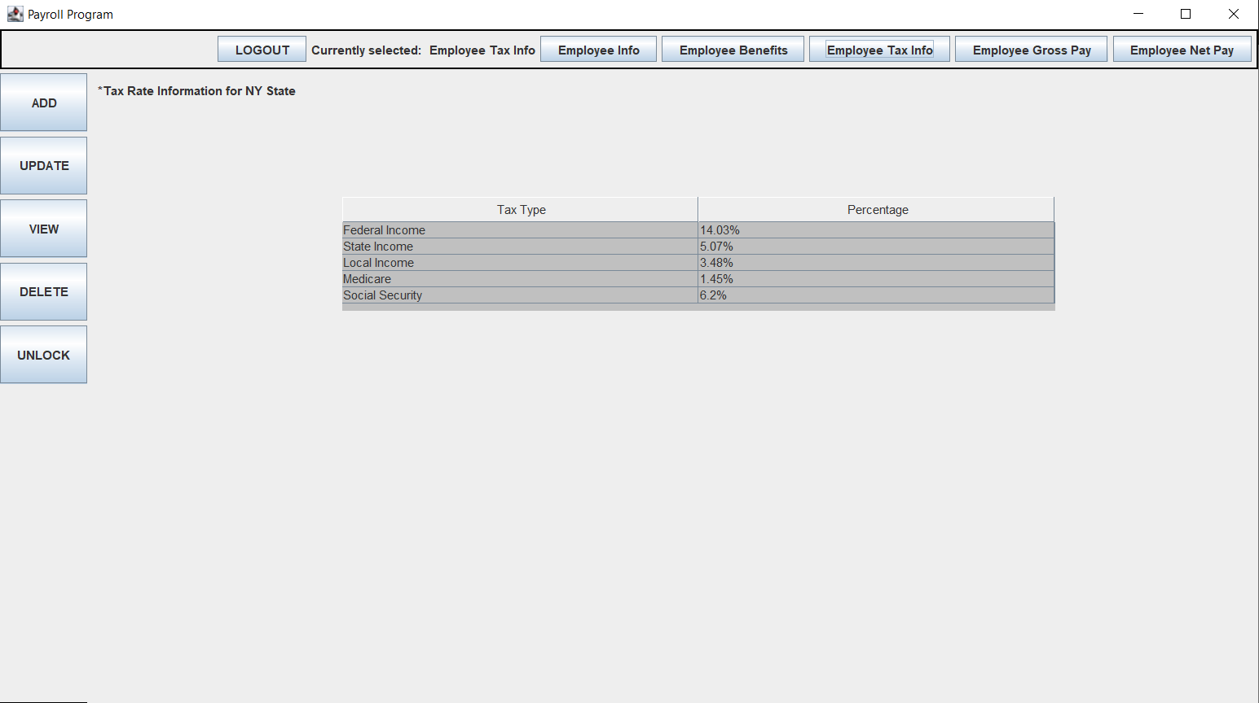

**HR Interface for Gross Pay**

On the “Employee Gross Pay” page, HR Members are able to input, modify, and delete the gross pay of a specific employee. The gross pay is the employee’s pay before the deduction of taxes and benefits, so it must be identical to the amount they were paid for that pay period.

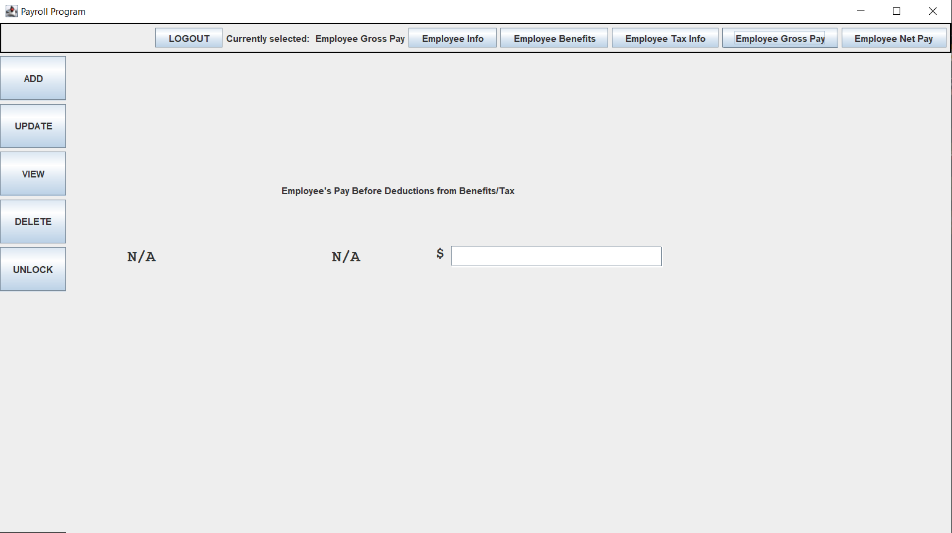

**Retrieving an Employee’s Gross Pay**

If an HR Member wishes to view an employee’s gross pay, they must input the employee’s ID# by clicking VIEW on the “Employee Gross Pay” page.

**Updating an Employee’s Gross Pay**

If an employee’s gross pay needs to be updated during the pay period, an HR Member can do this by inputting an employee’s new gross pay and clicking UPDATE on the left side of their screen.

**HR Interface for Net Pay**

The “Employee Net Pay” page shows an employee’s net income. The net income is the calculation of the employee’s gross income with the subtraction of taxes and benefits. Because it takes the gross income data from the “Employee Gross Pay” page, this page cannot be modified directly.

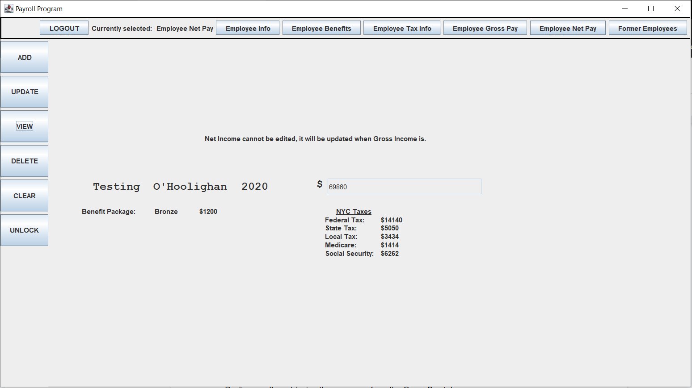

**Viewing an Employee’s Net Pay**

If an HR Member wishes to view an employee’s net pay, they click on the “VIEW” button and enter the employees ID Number as with the other tabs. We added some elements underneath the text field to show what was subtracted from the gross pay to calculate the net pay, such as the benefit package the employee is currently subscribed to, and the taxes from NYC.

**HR Interface for Former Employees**

On this new page, HR Members have the ability to view and edit the information of past employees of the company:

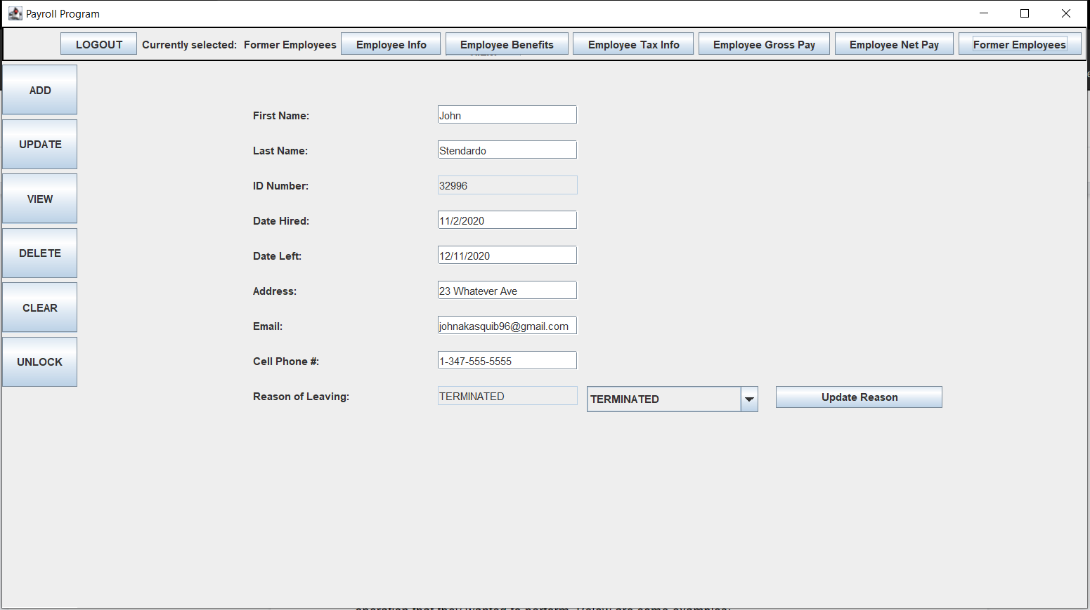

**Viewing Former Employee Information**

If an HR member wishes to view the information of a former employee, they must click on the “Former Employee” page, then click “VIEW” followed by inputting the former employee’s ID. The information shown is similar to that of the employee info panel, but the critical difference here is that nothing sensitive is shown, such as a social security number, for example.

**Editing Former Employee Information**

To edit a former employee’s information, HR members must click “UPDATE” on the left side of the screen, after editing whatever information they want in the text fields. Updating the reason of leaving for the employee is simple, just click the drop-down box and choose from one of the 4 reasons, QUIT, TERMINATED, DECEASED, or DISABLED. Hitting the ‘Update Reason’ button updates the field, but nothing will actually be updated in the back end untIl you press UPDATE.

**Error handling**

We have multiple error dialogs that will inform the user in case an error occurs during an operation that they wanted to perform. If the error was caused by something on the users part, we do our best to inform them of that, otherwise we just present a generic error dialog. Below are some examples:

